**ALIEN ATTACK!!!**

SOFTWARE ENGINEERING 1

CSCI 2113

Created By: Gregg Berne Legarda

THE GEORGE WASHINGTON UNIVERSITY

**TABLE OF CONTENTS**

Game Instructions-------------------------------------------------------------------------------------------------PG 1

Player Movement -------------------------------------------------------------------------------------------------PG 1

Buttons and Keys --------------------------------------------------------------------------------------------------PG 1

Damage and Player Size------------------------------------------------------------------------------------------PG 1

Points and Scoring-------------------------------------------------------------------------------------------------PG 1

Power Ups-----------------------------------------------------------------------------------------------------------PG 1

Graphics

Alien and Player-----------------------------------------------------------------------------------------PG 2

Sample Game Frame-----------------------------------------------------------------------------------PG 3

Top 10 High Scores -------------------------------------------------------------------------------------PG 4

**GAME INSTRUCTIONS**

Avoid getting hit by aliens by moving the spaceship across the screen.

**PLAYER MOVEMENT**

Player is a spaceship.

Move anywhere in the game screen using keyboard arrow buttons.

Spaceship can “zoom” through aliens without being damaged

**BUTTONS AND KEYS**

Keyboard arrows moves player across the screen.

Start button starts game and timer.

Pause button pauses game and timer.

End button resets board, score and player size.

**DAMAGE AND PLAYER SIZE**

Player starts off as a LARGE spaceship.

First damage turns player into a MEDIUM spaceship.

Second damage turns player into a SMALL spaceship.

Third damage, spaceship EXPLODES and game ends.

If aliens hit the space ship from the front, DAMAGE occurs.

If spaceship “zooms” through aliens, NO DAMAGE occurs.

**POINTS AND SCORING**

LARGE aliens are worth 50 points.

MEDIUM aliens are worth 25 points.

SMALL aliens are worth 10 points.

Points are rewarded when player successfully avoids alien and alien passes through game board.

**POWER UPS**

Power up docks appear every wave.

Spaceship returns to original LARGE size after docking.

**GRAPHICS**

Small Alien (30x30) Medium Alien (50x50) Large Alien (70x70)

  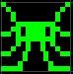

Small Spaceship (30x30) Medium Spaceship (50x50) Large Spaceship (70x70)

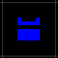 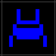 

Exploding Spaceship Power Up Dock (70x70) Empty Grid (70x70)

 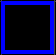 

**GRAPHICS**

Sample Game Frame (Paused):

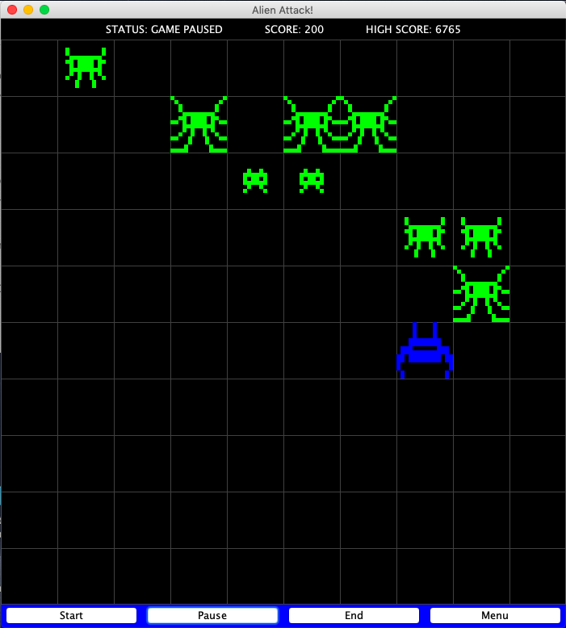

Board Size (700x700)

Grid Size (70x70)

Number of Grids (10x10)

**GRAPHICS**

Top 10 High Scores (End):

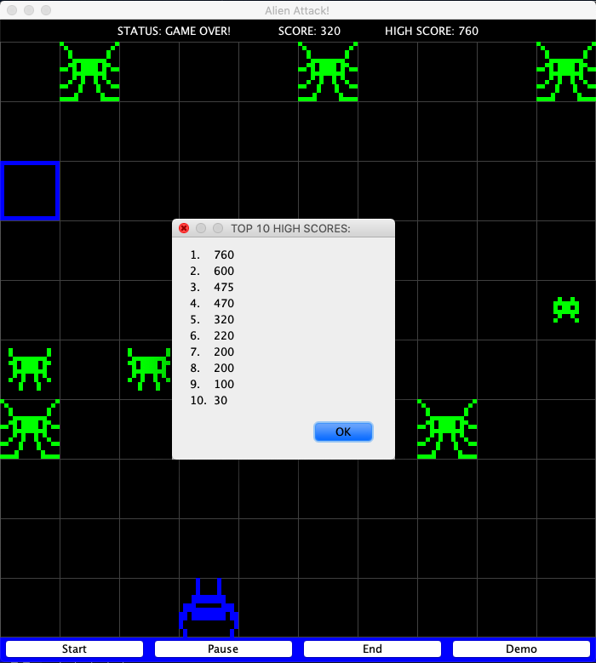

Pressing the “End” button will end the game and show the top 10 high scores.